**Tender Document**

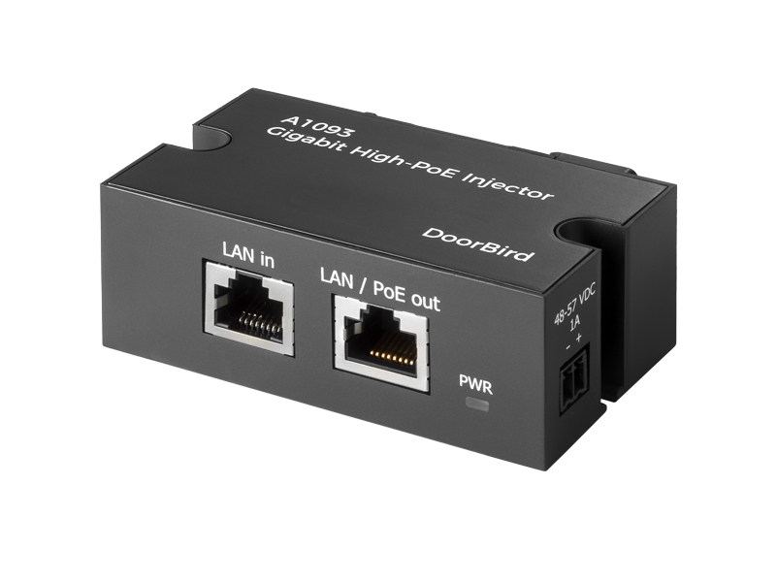

**Product Name**

Gigabit High-PoE-Injector A1093

**Short Description**

For transmitting power and data via one Ethernet cable

**Product Description**

* Provides power and data via an Ethernet cable for easy network expansion
* Compatible with High-Power PoE+ IEEE 802.3at and PoE IEEE 802.3af devices
* Up to 1000-Mbit/s Gigabit-Ethernet transmission speed
* Plug-and-play, no configuration required
* Simple and fast installation
* For mounting on walls, ceilings, or in control cabinets (DIN rail)

**Highlights and Details**

* Single cable solution Transmission of power and network data via one single cable
* For all DoorBird PoE devices Compatible with all PoE-capable door stations, access control devices and indoor stations
* PoE+/PoE support PoE+ IEEE 802.3at (30W max.) PoE IEEE 802.3af (15,4W max.)
* 10/100/1000 Mbit/s Supports flexible network speeds up to 1 GBit/s
* Plug-and-Play Simple and fast installation – no configuration required
* Ultra-compact housing For mounting on walls, ceilings, or in control cabinets (DIN rail)
* Transmission distance Max. 80 m/262 ft

**Product Weight**

525 gm

**Delivery time**

Delivery within 4 business days!

**Datasheet**

[datasheet_a1093_en.pdf (doorbird.com)](https://doorbird.com/downloads/datasheet/datasheet_a1093_en.pdf)

**Often Ordered As Well**

* D2101V IP Video Intercom
* D1101V Flush-mount IP Video Intercom
* A1121 Flush-mount IP Access Control Device
* IP Video Indoor Station A1101 White Edition
* 2-wire Ethernet PoE Converter A1071
* IP I/O Door Controller A1081